Design of Low-cost Autonomous Water Quality Monitoring System

Aravinda S. Rao∗, Stephen Marshall†, Jayavardhana Gubbi∗, Marimuthu Palaniswami∗, Richard Sinnott‡, and Vincent Pettigrove†

∗ ISSNIP, Department of Electrical and Electronic Engineering, The University of Melbourne, Parkville Campus, VIC - 3010, Australia.

[aravinda@student.unimelb.edu.au,](mailto:aravinda@student.unimelb.edu.au) {jgl, palani}@unimelb.edu.au

† CAPIM, Department of Zoology, The University of Melbourne, Parkville Campus, VIC - 3052, Australia.

s.marshall@zoology.unimelb.edu.au,vpet@unimelb.edu.au

‡ Melbourne eResearch Group, The University of Melbourne, Parkville Campus, VIC - 3010, Australia.

[rsinnott@unimelb.edu.au](mailto:rsinnott@unimelb.edu.au)

***Abstract*—Good water quality is essential for the health of our aquatic ecosystems. Continuous water quality monitoring is an important tool for catchment management authorities, pro- viding real-time data for environmental protection and tracking pollution sources; however, continuous water quality monitoring at high temporal and spatial resolution remains prohibitively expensive. An affordable wireless aquatic monitoring system will enable cost-effective water quality data collection, assisting catchment managers to maintain the health of aquatic ecosystems. In this paper, a low-cost wireless water physiochemistry sensing system is presented. The results indicate that with appropriate calibration, a reliable monitoring system can be established. This will allow catchment managers to continuously monitoring the quality of the water at higher spatial resolution than has previously been feasible, and to maintain this surveillance over an extended period of time. In addition, it helps to understand the behavior of aquatic animals relative to water pollution using data analysis.**

1. INTRODUCTION

Maintaining good water quality in rivers and streams bene- fits both humans and aquatic ecosystems. Water is the essential element for humans to live. Equally, this principle applies to amphibians and aquatic animals. Any imbalance in water quality would severely affect the health of the humans and simultaneously affect the ecological balance among species. Hence, it is of prime importance to protect the quality of water.

Water pollution remains a key factor contributing to de- clining ecological health in aquatic ecosystems worldwide. In Australia, the state of Victoria is facing a major challenge in maintaining water quality in the freshwater systems. Nearly 80% of waterways in Victoria are in poor to moderate condi- tion [1] and there has been little improvement from previous years. Remediation efforts are hampered by the difficulty of diagnosing the causes of environmental degradation. Currently, low-resolution water quality monitoring is conducted, and water samples are collected at regular periods for chemical analysis in the laboratory. The disadvantages of this approach are: (a) data collection is patchy in space and time, so sporadic pollution events can easily be missed; (b) it is time-consuming and expensive for personnel to collect water samples, return to

laboratory to test and repeat the same procedure for different water resources; (c) there are certain biological and chemical processes such as oxidation-reduction potential that need to be measured on-site to ensure accuracy; (d) laboratory testing has a much slower turnaround time compared with on-site monitoring; (e) interpretation of data collected across different seasons is difficult, as the data is sparse both in space and time.

Simultaneous water quality surveillance across multiple tributaries allows catchment managers to detect spatial trends in water conditions in real-time. Higher resolution data would allow instant diagnosis of pollution sources and greatly assist catchment managers in assessing the impact of remediation efforts, but the expense of deploying current monitoring tech- nology at multiple sites is prohibitive. Therefore, there is a need for real-time, on-site, water quality monitoring systems which can deliver continuous data of high quality at an acceptable cost.

The objective of our work is to develop a low-cost, wireless water quality monitoring system that aids in continuous mea- surements of water conditions. Our contribution in this work is the system-level integration of biosensors, sensor signal processing, and sensor data management. In this regard, we developed a prototype sensor as one component of the Au- tonomous Live Animal Response Monitor (ALARM) currently under development at the Victorian Center for Aquatic Pollu- tion Identification and Management (CAPIM). As an important component of the ALARM biosensor, our system was designed to measure a suite of biologically relevant physiochemical parameters in freshwater. We measured temperature, light in- tensity, pH, electrical conductivity (EC), total dissolved solids (TDS), salinity (SAL), dissolved oxygen (DO) and oxidation reduction potential (ORP). These parameters provide insights into the current status of changing water conditions and assist in identifying pollution sources. Our system was tested at CAPIM by measuring these parameters continuously for one month in parallel with a commercial water quality monitor.

The paper is organized as follows: Section II provides an overview of similar existing systems. Section III places our

developed prototype system in context, and outlines the key features of the component sensors. In addition, it also provides details about how sensor values are acquired and processed. Section IV provides the preliminary comparison of results, followed by conclusion in Section V.

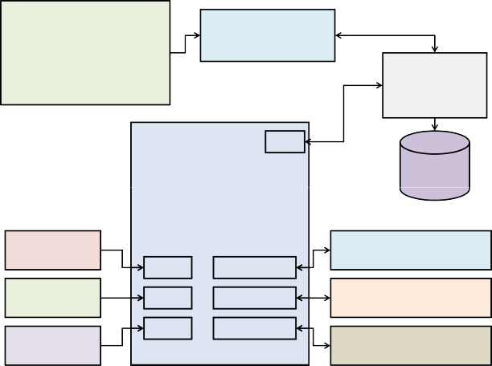

Temperature pH Conductivity

Dissolved Oxygen

Oxidation Reduction Potential

TPS90−FLT RS232

Water Quality Meter to USB

USB

Computer

TPS Sensors

USB

Arduino Mega 2560

SQL

Database

Temperature (Phidgets)

ADC 0

RS232 Port 1

Electrical Conductivity (Atlas Scientific)

pH

(Atlas tific)

Scien

ADC 1 RS232 Port 2

Dissolved Oxygen (Atlas Scientific)

Light (Phidgets)

ADC 2 RS232 Port 3

Oxidation Reduction Potential (Atlas Scientific)

USB

1. RELATED WORK

Many wireless sensor network (WSN) based systems exist. Each of the systems are designed to cater for individual applications and need. In this section we look at some of them relevant to our system. O’Flyrm *et al.* [2] designed a multi- sensor system to meet the requirements of the Water Frame- work Directive (WFD), a European Union (EU) policy to help improve the water quality and the ecology. They used ZigBee standards for communication and the system accommodated six Plug-and-Play sensors based on Tyndall mote [3]. They measured temperature, pH, phosphate, dissolved oxygen, con- ductivity, turbidity and water levels. Dinh *et al.* [4] used WSN for measuring salinity and underground water level. They used Fleck3 platform [5] (uses Atmel Atmega128 processors) for sensor node deployment. They measured salinity, water level, water flow rate, and flow volume. Furthermore, Chaamwe [6] stresses the fact WSN is suitable for water quality monitoring. Zennaro *et al.* [7] used Sun SPOT motes [8] to measure the quality of water. They used 90−FLT series E sensor by TPS to measure pH, conductivity. TDS, DO, turbidity and temperature. The authors reported that it costed around $3*,* 400. The purpose of this work is to provide cost-efficient and nearly accurate measurements using sensor networks for continuous monitoring of aquatic environment. The above methods are not suitable for long-term outdoor environments.

On the other hand, apart from WSN systems that are local, there are several systems that monitor water quality and report using telecommunication networks. Rao *et al.* [9] demonstrated the use of WSN and GSM for tracking vehicles and mentioned the fact that it can be used for water quality measurement purposes. They used Short Message Service (SMS) as a means to transfer data. Nasirudin *et al.* [10] used PIC16F886 as sensor node and GSM modems for updating the central database. Measurements included temperature, pH, turbidity and DO. Wang *et al.* [11] used Atmel’s AT91R40008 microprocessor as sensor node and proposed Code Division Multiple Access (CDMA) based data transfer mechanism. Wang *et al.* [11] measured DO, pH and conductivity for monitoring water quality. An example of use of WiMAX is also found in [12]. Sensors included pH, conductivity, temperature, ORP, and DO.

1. OUR SYSTEM

In this paper, a prototype system is reported. This system was developed as one component of the Autonomous Live Ani- mal Response Monitor (ALARM) toxicity biosensor, designed to be deployed in-stream for continuous monitoring. Fig. 1 shows the overview of our system. Note that when integrated into the ALARM biosensor, the computer in the flow chart will be replaced by the Beagleboard-XM ARM processor equipped with multiple high-speed USB ports for other sensors and a variety of communication interfaces such as 3G, 4G and WiFi.

Fig. 1: Overview of our prototype and data collection proce- dure

1. *Sensor Node*

Arduino Mega 2560 [13] is used as our sensor node to acquire and process sensor data. Arduino Mega 2560 was chosen because it is an open-source product, inexpensive and provides sufficient analog/digital pins for our applications. The unused pins in our work are meant for addition of hardware and other sensors in future. It operates at 5V using Atmel’s ATmega2560 micro-controller with a clock speed of 16 MHz. It has a flash memory of 256 kB and Static Random Access Memory (SRAM) of 8 kB. Of all the Arduino boards, Mega dominates in terms of processing, memory and number of available interconnections. It has 16 analog pins and 4 serial ports. One of the serial ports is connected internally to Universal Serial Bus (USB) port. We have used three analog pins and all the 4 serial ports for application.

1. *Sensors*

This section supplies information about the sensors used in our system. Table I summarizes the sensor specifications.

*l) pH:* The system uses pH sensor from Phidgets [14].It measures the full pH range from 0 to 14 and operates in the temperature range of 0◦ − 80◦ C. The sensor is terminated via BNC connection. The Phidgets also supplies adaptor to convert BNC to analog voltage after sensing. Using this adaptor, the pH sensor data is acquired at Arduino analog pin.

1. *Light:* Similar to pH sensor, light sensor from Phidgets is used in our prototype. It can operate at 3.3V and 5V. In our system all sensors are being operated at 5V. The range of light intensity can be measured from 0 − 1000 lx and sensor output is of non-ratiometric type.
2. *Temperature:* The temperature sensor used is the system is from Atlas Scientific [15]. It has a wide temperature range of −20◦ to 133◦ C, with ±1 C accuracy and operates up to 5*.*5V. This was chosen because it is a field-ready temperature and is water tight and nonreactive to salt waters, which are the important properties for sensors placed in water continuously. This sensor is interfaced directly to Arduino analog pin.

TABLE I: Summary of sensor specifications used in our system



|  |  |  |  |
| --- | --- | --- | --- |
| **Sensor** | **Manufacturer** | **Model Range** | |
| pH | Phidgets | 3550 0 - ASP200-2-1M-BNC pH Lab Electrode 0 − 14 | |
| Light Phidgets 1127 0 - Precision Light Sensor 0 − 1000 lx | | | |
| Temperature | Atlas Scientific | ENV-TMP Field Ready Temperature Sensor | −20◦ C to +130◦ C |
| Electrical Conductivity | Atlas Scientific | Conductivity Sensor | (K=1), 1, 300 − 40, 000 μS |
| Dissolved Oxygen | Atlas Scientific | D.O.Sensor | 0 − 20 mg/L |
| Oxidation Reduction Potential | Atlas Scientific | ORP Sensor | ±2000 mV |

Start

Acquire Temperature (T), Light, pH

No Is T

acquire?

Yes

Acquire EC, TDS, SAL

First, when the Arduino boots up, serial port initialization is carried out with the EC, DO and ORP circuits to communicate with Arduino. The serial port settings for all three circuits were 38400,8,N,1. Next, the Arduino waits for 5 seconds and starts acquiring temperature, light and pH. The temperature information will be provided as input to the EC circuit to measure EC, TDS and SAL. The Arduino is programmed in such a way that it waits for a predefined time until the results are obtained. If Arduino does not receive EC data, it quits

Are T & Yes

EC Acquire DO

acquired?

the current cycle of acquiring sensor data and discards any other sensor data. Upon receiving temperature data, Arduino then issues command to DO circuit with both temperature and conductivity values. The DO circuit in return would provide

No Is DO

available ?

Yes

Acquire ORP

temperature and conductivity compensated value. If Arduino does not receive this data within predefined time, it will quit the current cycle. Next, upon receiving DO data, it acquires ORP data and sends the data to computer.

Fig. 2: Data acquisition process by Arduino from different

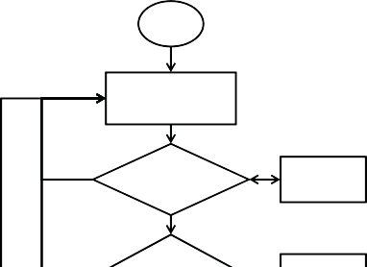

sensors

1. *Electrical Conductivity:* Scientific-grade platinum con- ductivity sensor from Atlas Scientific is used as an electrical conductivity sensor. *K* = 1 conductivity sensor was used that measures the conductivity in the range 1*,* 300 − 40*,* 000 *μ*S. The output of the sensor value is fed to an EC circuit that provides the results in the RS232 format. This is interfaced to one of the serial ports of Arduino. The sensor can also output the temperature compensated conductivity by issuing proper commands via Arduino. Electrical conductivity sensor also outputs total dissolved salts (TDS) and salinity values along with EC values.
2. *Dissolved Oxygen:* Galvanic dissolved oxygen sensor is similar to EC probe and measures dissolved oxygen content in the range of 0−20 mg/L. It operates to a maximum temperature of 50◦ C. The output of dissolved oxygen is fed to a DO circuit that provides the results in RS232 format. This is interfaced to the second serial port of Ardunio Mega 2560.
3. *Oxidation Reduction Potential:* The ORP sensor mea- sures oxidation-reduction potential in the range of ±2000 mV. This is connected to an ORP circuit for processing before being connected to the third serial port of the Arduino.
4. *Software*

Arduino Mega 2560 was programmed using Arduino IDE. The functions and the structures are similar to C and C++. There are some special string functions available dedicated to Arduino. The process of acquiring data from sensors is shown in Fig. 2.

1. *Base Station*

A computer was programmed to receive Arduino data via USB. TPS water quality meter was also connected to another USB port of the computer, where the time stamped data is stored in MySQL database. Both Arduino and TPS sensors were submerged (except light sensor) into a glass tub for taking measurements.

1. RESULTS AND DISCUSSION

21

Arduino Temperature Sensor Output

TPS Temperature Sensor Output

20.8

20.6

20.4

Temperature (in degree Celcius)

20.2

20

19.8

19.6

19.4

19.2

190 1000 2000 3000 4000 5000 6000 7000 8000 9000

Time (in seconds)

Fig. 3: Comparison of temperature sensor values

The prototype version and complete overview of the system can be found in Fig. 4. The comparison of temperature, DO,

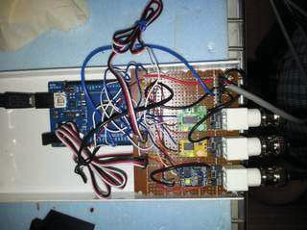 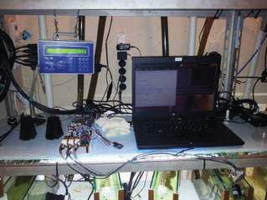 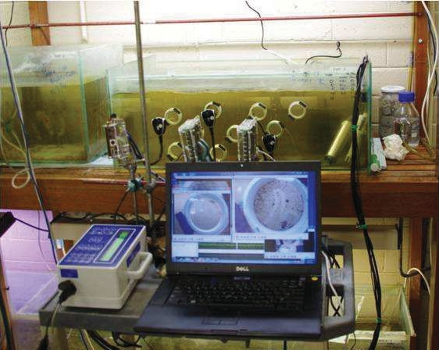

* 1. (b) (c)

Fig. 4: (a) prototype of the system with Arduino and sensors, (b) prototype of the system with Arduino, TPS and sensors, (c) monitoring of aquatic animals.

(a)

12

Arduino DO Sensor Output TPS DO Sensor Output

10

Disolved Oxygen (mg/L)

8

6

4

2

0

2500

2000

Electrical Conductivity (uS)

1500

1000

500

0

(c)

–20 2000 4000 6000 8000 10000

Time (in seconds)

12



Arduino pH Sensor Output TPS pH Sensor Output

10

8

6

pH

4

2

0

–20 2000 4000 6000 8000 10000

Time (in seconds)

–5000 2000 4000 6000 8000 10000

Time (in seconds)

Arduino EC Sensor Output TPS EC Sensor Output

(d)

0.8

Arduino ORP Sensor Output TPS ORP Sensor Output

Oxidation Reduction Potential (V)

0.6

0.4

0.2

0

–0.20 2000 4000 6000 8000 10000

Time (in seconds)

Fig. 5: Comparison of time domain analysis of raw, uncalibrated sensor values. (a) raw dissolved oxygen readings, (b) raw pH readings, (c) raw electrical conductivity readings, (d) raw oxidation reduction potential readings.

pH, EC and ORP between Arduino sensors’ output and TPS sensors are provided respectively in Figs. 3, 5-(a), 5-(b), 5-

* 1. and 5-(d). During data collection, the water condition was altered manually to observe changes in the sensor values. The sensors were sampled at every 10s. Figs. 3, 5-(a), 5-(b), 5-(c) and 5-(d) reflect this sampling time along *y* axis. Therefore, the total number of samples obtained for each sensor in a day amounts to 8640 samples. Equiripple band-pass filter was used to process the raw signals.

In Fig. 3 we see that temperature values from both the

sensors almost coincide with each other as we progress along time axis. Although it may appear that there is large difference in values, but actually, the difference between standard test instrument and Arduino sensor outputs are negligible.

Fig. 6 provides comparison of frequency analysis for DO, pH, EC and ORP. The frequency analysis was computed using 512-point Fast Fourier Transform (FFT). Fig. 6-(a) shows the variations for DO sensor, Fig. 6-(b) shows the variations in pH values. All the sensors presented here are calibrated individually, but are uncalibrated with respect to standard

0.1

0.08

Normalized |Y(f)|

(a)

0.1

Arduino–DO Sensor TPS–DO Sensor

0.08

Normalized |Y(f)|

(c)

0.06 0.06

Arduino–EC Sensor TPS–EC Sensor

0.04 0.04

0.02

00

0.1

Arduino–PH Sensor TPS–PH Sensor

0.08

Normalized |Y(f)|

0.05 0.1 0.15 0.2

Frequency (Hz) (b)

0.02

00

0.1

Arduino–ORP Sensor TPS–ORP Sensor

0.08

Normalized |Y(f)|

0.05 0.1 0.15 0.2

Frequency (Hz) (d)

0.06 0.06

0.04 0.04

0.02

00

0.05 0.1 0.15 0.2

Frequency (Hz)

0.02

00 0.05 0.1 0.15 0.2

Frequency (Hz)

Fig. 6: Comparison of frequency domain analysis of raw, uncalibrated sensor values. (a) frequency spectrum of dissolved oxygen readings, (b) frequency spectrum of pH readings, (c) frequency spectrum of electrical conductivity readings, (d) frequency spectrum of oxidation reduction potential readings.

benchmark instruments. Similarly, Fig. 6-(c) and Fig. 6-(d) show the variations of EC and ORP sensors. It is evident that variations match for DO, pH and EC sensors perfectly. The ORP variations in Fig. 6-(d) are in the acceptable range. It is important to note the fact variations are linear for each of the comparison. This essentially provides us information to calibrate the sensors at the post-processing stage. Since the variations are linear, we can fit a model for eachof the sensors.

The Arduino is programmed in such a way that if any of the sensors do not respond, then it will quit the current cycle of data acquisition. It is important to have this functionality to avoid permanent cease to data acquisition beauts of a single sensor. Similarly, computer also has a piece of script that monitors the activities of Arduino. In fact, computer sends timely commands to Arduino to acquire data. If there is no response from the Arduino, the software on the computer will reset the power of Arduino. In the results, the data was sampled at every 10 s. However, Arduino can sample at every 5 s stably without overloading sensors and the system.

The system cost, including Arduino, sensors, SBC and 4G modem, stands at $1*,* 040, this is in stark contrast to commer- cial water quality monitoring systems $3*,* 400 [7], which is a threefold reduction in cost. From the results shown above, with the use of low-cost and open-source hardware, we can achieve acceptable sensor readings. With the help of data calibration

(adjusting offset) at the server side (post processing), we can use this low-cost system for continuous water quality measurement that aids in studying aquatic behavior analysis and also provide insights into source of water pollution.

1. CONCLUSION

In this work, the design and demonstration of a pro- totype low-cost, continuous water-quality monitoring system is described. The system uses low-cost sensors and open- source hardware aimed at providing continuous water quality measurements at lower cost. The system uses low-cost sensors and open-source hardware to deliver continuous measurement of water quality at substantially reduced cost. Preliminary re- sults demonstrate that with appropriate calibration and signal- processing, the prototype can maintain accurate results over an extended period of time. We conclude the prototype is suitable for field deployment to provide continuous long- term water quality measurement, both as a component of the ALARM biosensor, and as a stand-alone instrument. This system delivers reliable, continuous water physiochemistry data at much lower cost than existing technology, allowing catchment managers to substantially improve the spatial and temporal resolution of water quality surveillance. In addition to the explicit benefits in monitoring, it helps to understand the behavior of aquatic animals relative to water pollution using data analysis.

ACKNOWLEDGMENT

The Autonomous Live Animal Response Monitor (ALARM) project was jointly funded by CAPIM and the Victorian Government to help develop real time pollution detection systems. The authors acknowledge the contributions of the ALARM project management committee: Dr Vincent Pettigrove of CAPIM, Prof Richard Sinnott of the University of Melbourne eResearch, Anne-Maree Westbury of the Victorian EPA, and Dr. Steven Manos of the University of Melbourne.

REFERENCES

1. V. D. of Sustainability and Environment, “Monitoring and reporting - results,” April 2012. [Online]. Available: <http://www.water.vic.gov.au/> monitoring/river-health/isc/results
2. B. O’Flyrm, R. Martinez, J. Cleary, C. Slater, F. Regan, D. Diamond, and H. Murphy, “Smartcoast: A wireless sensor network for water quality monitoring,” in *32nd IEEE Conference on Local Computer Networks (LCN 2007)*. IEEE, 2007, pp. 815–816.
3. T. N. Institute, “Wireless sensor network (wsn) developement,” April 2013. [Online]. Available: https[://w](http://www.tyndall.ie/content/mote-layers)ww.[tyndall.ie/content/mote-layers](http://www.tyndall.ie/content/mote-layers)
4. T. L. Dinh, W. Hu, P. Sikka, P. Corke, L. Overs, and S. Brosnan, “Design and deployment of a remote robust sensor network: Experiences from an outdoor water quality monitoring network,” in *32nd IEEE Conference on Local Computer Networks (LCN 2007)*. IEEE, 2007, pp. 799–806.
5. CSIRO, “Wireless sensor network devices,” April 2013. [Online].

Available: <http://www.ict.csiro.au/page.php?cid=87>

1. N. Chaamwe, “Wireless sensor networks for water quality monitoring: A case of zambia,” in *20l0 4th International Conference on Bioinfor- matics and Biomedical Engineering (iCBBE)*. IEEE, 2010, pp. 1–6.
2. M. Zennaro, A. Floros, G. Dogan, S. Tao, C. Zhichao, H. Chen,

M. Bahader, H. Ntareme, and A. Bagula, “On the design of a water quality wireless sensor network (wqwsn): An application to water quality monitoring in malawi,” in *International Conference on Parallel Processing Workshops (ICPPW ’09)*. IEEE.

1. S. SPOT, “Sunspot world - progam the world,” April 2013. [Online].

Available: <http://www.sunspotworld.com/>

1. A. S. Rao, D. Izadi, R. F. Tellis, S. W. Ekanayake, and P. N. Pathirana, “Data monitoring sensor network for bignet research testbed,” in *2009 5th International Conference on Intelligent Sensors, Sensor Networks and Information Processing (ISSNIP)*. New York, USA: IEEE, 2009, pp. 169–173.
2. M. A. Nasirudin, U. N. Za’bah, and O. Sidek, “Fresh water real-time monitoring system based on wireless sensor network and gsm,” in *20ll IEEE Conference on Open Systems (ICOS)*. IEEE, 2011, pp. 354–357.
3. J. Wang, X. li Ren, Y. li Shen, and S.-Y. Liu, “A remote wireless sensor networks for water quality monitoring,” in *20l0 International Confer- ence on Innovative Computing and Communication and 20l0 Asia- Pacific Conference on Information Technology and Ocean Engineering (CICC-ITOE)*. IEEE, 2010, pp. 7–12.
4. S. Silva, N. Hoang Nghia, V. Tiporlini, and K. Alameh, “Web based water quality monitoring with sensor network: Employing zigbee and wimax technologies,” in *High Capacity Optical Networks and Enabling Technologies (HONET)*. IEEE, 2011, pp. 138–142.
5. Arduino, “Arduno mega 2560,” April 2013. [Online]. Available: <http://arduino.cc/en/Main/arduinoBoardMega2560>
6. “Phidgets,” April 2013. [Online]. Available: <http://www.phidgets.com/>
7. “Atlasscientific - biology, technology,” April 2013. [Online]. Available: <http://atlas-scientific.com/>